Faith – the servant of the believer

How do you please God

Hebrews 11:6
⁶ But without faith it is impossible to please him: for he that cometh to God must believe that he is, and that he is a rewarder of them that diligently seek him.

Who has faith

Romans 12:3
³ For I say, through the grace given unto me, to every man that is among you, not to think of himself more highly than he ought to think; but to think soberly, according as God hath dealt to every man the measure of faith.
Wicked Men do not have faith

2 Thessalonians 3:2
² And that we may be delivered from unreasonable and wicked men: for all men have not faith.

Faith is the core element required to receive from God

It takes faith to believe what you are asking God for

Mathew 21:22
And all things, whatsoever ye shall ask in prayer, believing, ye shall receive.

What is Faith

Our faith is the evidence of the things that we hope for

Hebrews 11:1
Now faith is the substance of things hoped for, the evidence of things not seen.

How does Faith come?

Point 1B: How does Faith come?

Faith comes by hearing the word of God. If you speak the word of God, your ears will hear it, and Faith will come faster because you believe your own words more than anyone else’s. Faith will then get down into your heart

Romans 10:17
So then faith cometh by hearing, and hearing by the word of God.

God’s word must be in your heart in abundance

Point 1C: You must put God’s word in your heart in abundance.

What is the source that your mouth speaks from?

Mark 12:34
…for out of the abundance of the heart the mouth speaks

How is Faith released? By Speaking

Matthew 17:20

20 And Jesus said unto them, Because of your unbelief: for verily I say unto you, If ye have faith as a grain of mustard seed, ye shall say unto this mountain, Remove hence to yonder place; and it shall remove; and nothing shall be impossible unto you.

Mark 11:23
For verily I say unto you, That whosoever shall say unto this mountain, Be thou removed, and be thou cast into the sea; and shall not doubt in his heart, but shall believe that those things which he saith shall come to pass; he shall have whatsoever he saith.

You say, don’t doubt in your heart, and believe – that those things which you say will come to pass, you will have whatsoever you say



Luke 17:6
⁶ And the Lord said, If ye had faith as a grain of mustard seed, ye might say unto this sycamine tree, Be thou plucked up by the root, and be thou planted in the sea; and it should obey you.


John 16:23
…Verily, verily, I say unto you, Whatsoever ye shall ask the Father in my name, he will give it you.

How is Faith released? By Speaking
Job 22:28
²⁸ Thou shalt also decree a thing, and it shall be established unto thee: and the light shall shine upon thy ways.


How is Faith released? By Speaking

John 15:7
⁷ If ye abide in me, and my words abide in you, ye shall ask what ye will, and it shall be done unto you.

How is Faith released? By Prayer

Mark 11:24
24 Therefore I say unto you, What things soever ye desire, when ye pray, believe that ye receive them, and ye shall have them.
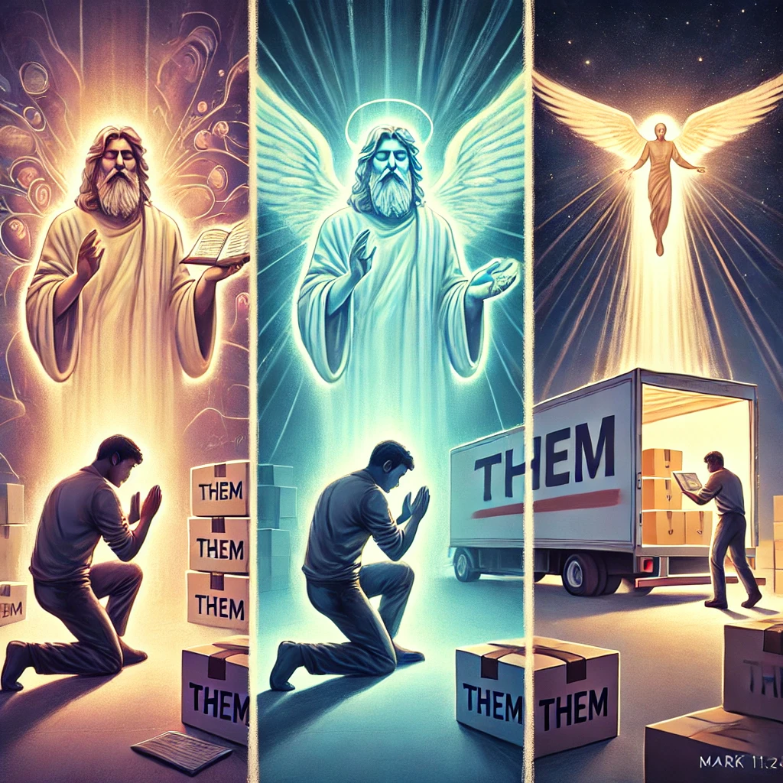
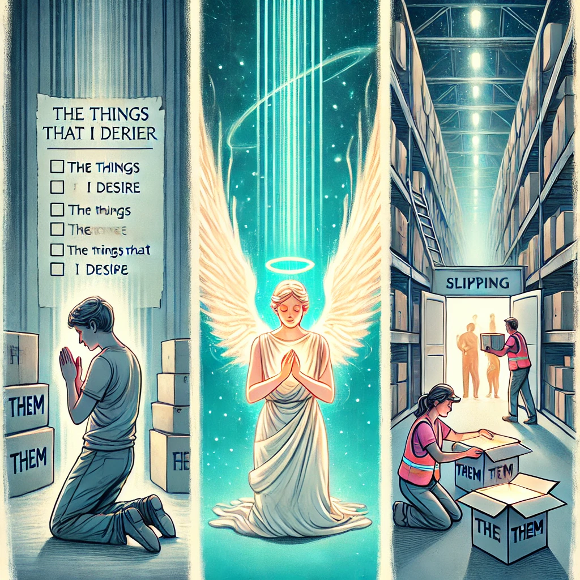
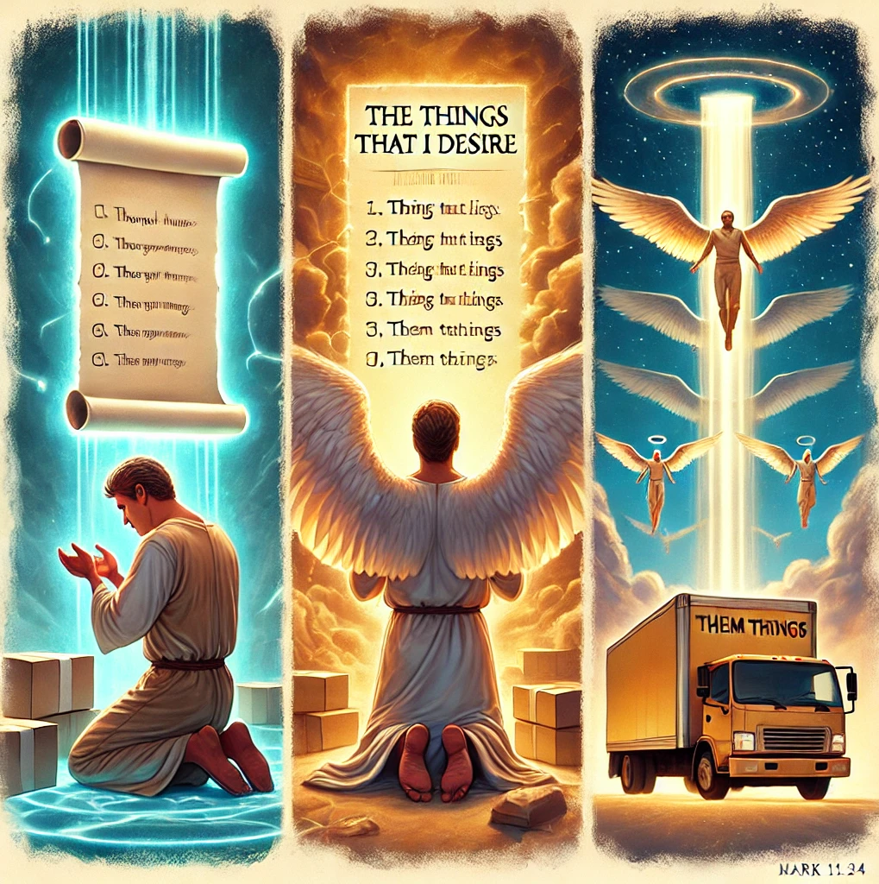

By thy words thou art justified

Matthew 12:37
³⁷ For by thy words thou shalt be justified, and by thy words thou shalt be condemned.

Death and Life – Controlled by your words
²¹ Death and life are in the power of the tongue: and they that love it shall eat the fruit thereof.
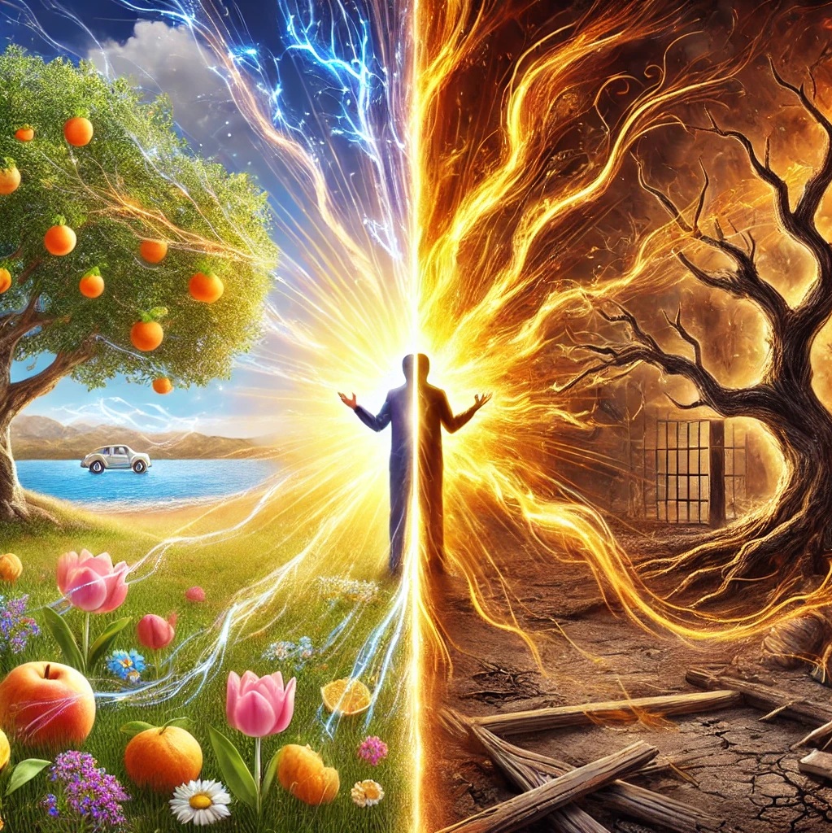

Hinderances to Faith
Fear is: False evidence appearing real
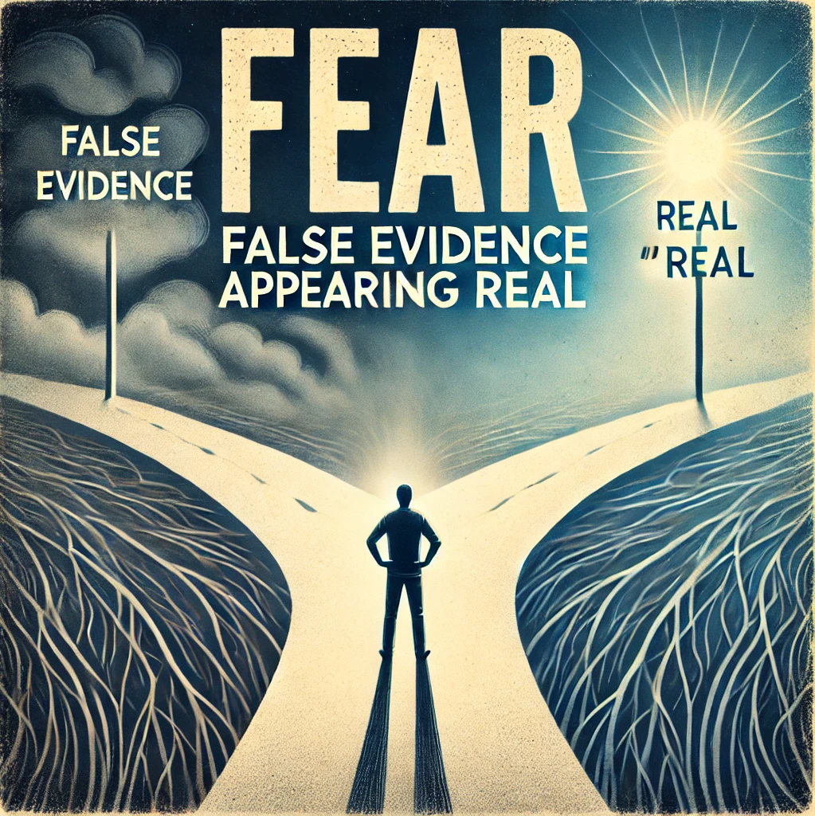


Doubt causes Faith to leave in stages

Matthew 14:27-31
²⁷ But straightway Jesus spake unto them, saying, Be of good cheer; it is I; be not afraid.
²⁸ And Peter answered him and said, Lord, if it be thou, bid me come unto thee on the water.
²⁹ And he said, Come. And when Peter was come down out of the ship, he walked on the water, to go to Jesus.
³⁰ But when he saw the wind boisterous, he was afraid; and beginning to sink, he cried, saying, Lord, save me.
³¹ And immediately Jesus stretched forth his hand, and caught him, and said unto him, O thou of little faith, wherefore didst thou doubt?

Faith without works is dead

James 2:17
¹⁷ Even so faith, if it hath not works, is dead, being alone.

When you are believing God for something – Write the vision

Given your faith vision

Habakkuk 2:2
² And the Lord answered me, and said, Write the vision, and make it plain upon tables, that he may run that readeth it.

Genesis 15:5
5 And he brought him forth abroad, and said, Look now toward heaven, and tell the stars, if thou be able to number them: and he said unto him, So shall thy seed be.

Faith the servant of the believer

Luke 17:5-9
⁵ And the apostles said unto the Lord, Increase our faith.
⁶ And the Lord said, If ye had faith as a grain of mustard seed, ye might say unto this sycamine tree, Be thou plucked up by the root, and be thou planted in the sea; and it should obey you.
⁷ But which of you, having a servant plowing or feeding cattle, will say unto him by and by, when he is come from the field, Go and sit down to meat?
⁸ And will not rather say unto him, Make ready wherewith I may sup, and gird thyself, and serve me, till I have eaten and drunken; and afterward thou shalt eat and drink?
⁹ Doth he thank that servant because he did the things that were commanded him? I trow not.

Whatever is not of faith is sin
To sin means to mis the Mark

Romans 14:23
²³ … for whatsoever is not of faith is sin.

