Spiritually Street Smart

Being street smart means having practical awareness, quick thinking, and the ability to navigate real-world situations with wisdom and discernment. It's not about academic knowledge—it’s about reading people, assessing danger, making sound decisions under pressure, and avoiding traps or deception in everyday life. A street-smart person often understands human nature, recognizes manipulation, and adapts swiftly in challenging environments.

In a biblical sense, being street smart reflects the kind of practical wisdom often described in Proverbs—not just knowing what is right, but knowing how and when to apply it. Jesus said, "Behold, I send you forth as sheep in the midst of wolves: be ye therefore wise as serpents, and harmless as doves." (Matthew 10:16). That’s the perfect image of spiritual street smarts: alert, wise, and discerning—yet still pure-hearted and faithful.

Book Smart – A Definition with Biblical Context
Being book smart means having strong academic knowledge, especially gained through study, reading, and formal education. A book-smart person often excels in understanding theories, facts, and structured learning. They can quote information, explain ideas clearly, and often think deeply and analytically.
However, being book smart doesn't automatically mean being wise in real-life situations. In the Bible, this kind of knowledge is valuable—but it’s also cautioned against when it’s not paired with understanding, humility, or discernment. Paul reminds us:
“Knowledge puffeth up, but charity edifieth.” – 1 Corinthians 8:1
In other words, knowledge alone can lead to pride, but love—and wisdom—builds up others.
God desires that His people grow in both knowledge and wisdom (Proverbs 4:7), meaning it’s good to be book smart—but even better to let that knowledge be shaped by spiritual maturity and real-world application.

Preparing to be Spiritually Street Smart

2 Timothy 2:15 – Study the word

Study to show thyself approved unto God, a workman who needeth not to be ashamed, rightly dividing the word of truth.

Proverbs 3:7 – Be not wise in thine own eyes
⁷ Be not wise in thine own eyes: fear the Lord, and depart from evil.

Romans 12:2 – Renew your mind
And be not conformed to this world, but be ye transformed by the renewing of your mind, that ye may prove what is that good and acceptable and perfect will of God.

Romans 12:3 – Don’t think of yourself more highly than you ought to think
³ For I say, through the grace given unto me, to every man that is among you, not to think of himself more highly than he ought to think; but to think soberly, according as God hath dealt to every man the measure of faith.

Micah 6:8 – What is the will of God?
⁸ He hath shewed thee, O man, what is good; and what doth the Lord require of thee, but to do justly, and to love mercy, and to walk humbly with thy God?

Hebrews 4:12 – Thoughts and intents are close today
¹² For the Word of God is living and powerful and sharper than any twoedged sword, piercing even to the dividing asunder of soul and spirit, and of the joints and marrow, and is a discerner of the thoughts and intents of the heart.

Matthew 17:21 – This is something you would only know through a steadfast study of the word
²¹ Howbeit this kind goeth not out but by prayer and fasting.
How do you determine counterfeit money from real money? You spend so much time around real money that you recommend the counterfeit when you come across it.

Matthew 12:37 – Don’t curse yourself, your stuff or other people
³⁷ For by thy words thou shalt be justified, and by thy words thou shalt be condemned.”

Proverbs 16:16
¹⁶ How much better is it to get wisdom than gold! and to get understanding rather to be chosen than silver!


Romans 14:13 – Don’t be a stumbling block
¹³ Let us not therefore judge one another any more: but judge this rather, that no man put a stumblingblock or an occasion to fall in his brother's way.


Ephesians 4:14 – Don’t listen to every wind and wave of doctrine – (Like You-Tube)
¹⁴ that we henceforth be no longer children, tossed to and fro and carried about with every wind of doctrine by the sleight of men and their cunning and craftiness, whereby they lie in wait to deceive;
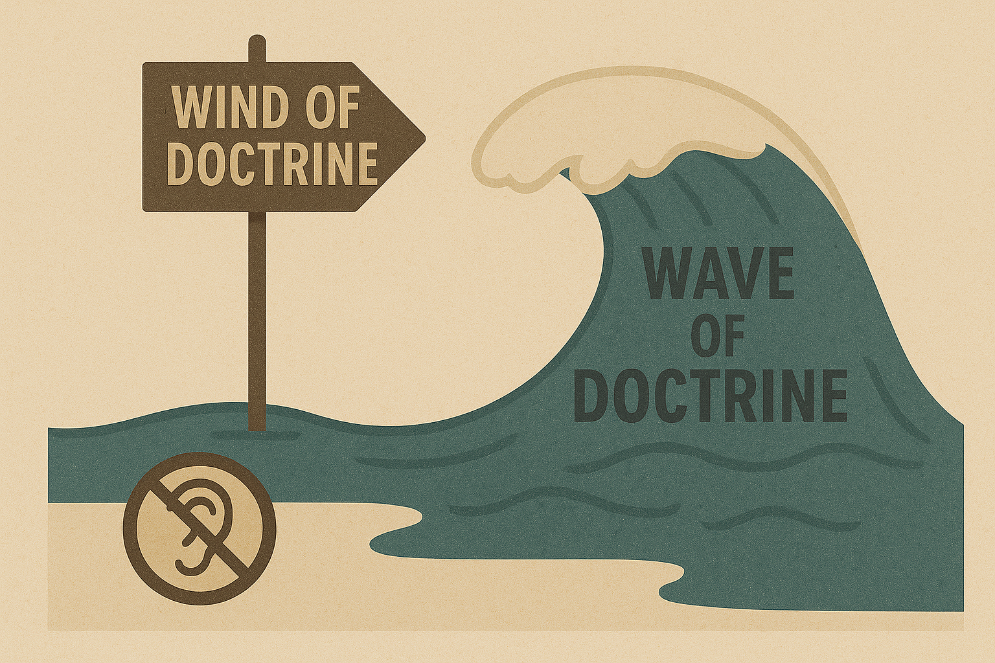

1 Peter 5:8 – Be sober and vigilant
⁸ Be sober, be vigilant; because your adversary the devil, as a roaring lion, walketh about, seeking whom he may devour:


Matthew 5:37 – Yes or no! No if’s and’s or butts!
³⁷ But let your communication be, Yea, yea; Nay, nay: for whatsoever is more than these cometh of evil.

How do you gain Discernment?

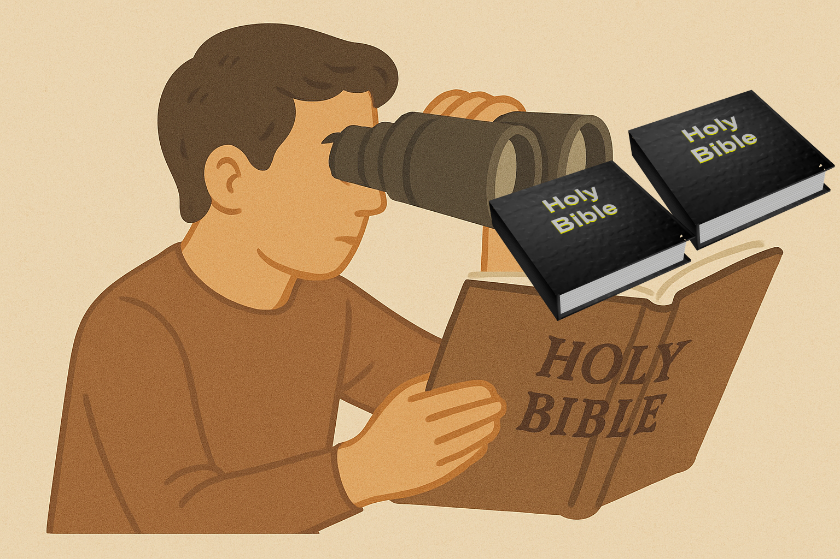

Proverbs 4:20-27 – Keep God’s sayings In the midst of your heart
²⁰ My son, attend to my words; incline thine ear unto my sayings.
²¹ Let them not depart from thine eyes; keep them in the midst of thine heart.
²² For they are life unto those that find them, and health to all their flesh.
²³ Keep thy heart with all diligence; for out of it are the issues of life.
²⁴ Put away from thee a froward mouth, and perverse lips put far from thee.
²⁵ Let thine eyes look right on, and let thine eyelids look straight before thee.
²⁶ Ponder the path of thy feet, and let all thy ways be established.
²⁷ Turn not to the right hand nor to the left: remove thy foot from evil.

Do you know what God said?

Genesis 3:1-19
3 Now the serpent was more subtle than any beast of the field which the Lord God had made. And he said unto the woman, “Yea, hath God said, ‘Ye shall not eat of every tree of the garden’?”
² And the woman said unto the serpent, “We may eat of the fruit of the trees of the garden,
³ but of the fruit of the tree which is in the midst of the garden, God hath said, ‘Ye shall not eat of it, neither shall ye touch it,lest ye die.’”
⁴ And the serpent said unto the woman, “Ye shall not surely die;
⁵ for God doth know that in the day ye eat thereof, then your eyes shall be opened, and ye shall be as gods, knowing good and evil.”
⁶ And when the woman saw that the tree was good for food, and that it was pleasant to the eyes, and a tree to be desired to make one wise, she took of the fruit thereof and ate, and gave also unto her husband with her; and he ate.
⁷ And the eyes of them both were opened, and they knew that they were naked; and they sewed fig leaves together, and made themselves things to gird about.
⁸ And they heard the voice of the Lord God, walking in the garden in the cool of the day. And Adam and his wife hid themselves from the presence of the Lord God amongst the trees of the garden.
⁹ And the Lord God called unto Adam and said unto him, “Where art thou?”
¹⁰ And he said, “I heard Thy voice in the garden, and I was afraid because I was naked; and I hid myself.”
¹¹ And He said, “Who told thee that thou wast naked? Hast thou eaten of the tree whereof I commanded thee that thou shouldest not eat?”
¹² And the man said, “The woman whom Thou gavest to be with me, she gave me of the tree, and I ate.”
¹³ And the Lord God said unto the woman, “What is this that thou hast done?” And the woman said, “The serpent beguiled me, and I ate.”
¹⁴ And the Lord God said unto the serpent, “Because thou hast done this, thou art cursed above all cattle, and above every beast of the field. Upon thy belly shalt thou go, and dust shalt thou eat all the days of thy life.
¹⁵ And I will put enmity between thee and the woman, and between thy seed and her Seed; It shall bruise thy head, and thou shalt bruise His heel.”
¹⁶ Unto the woman He said, “I will greatly multiply thy sorrow and thy conception. In sorrow thou shalt bring forth children; and thy desire shall be to thy husband, and he shall rule over thee.”
¹⁷ And unto Adam He said, “Because thou hast hearkened unto the voice of thy wife, and hast eaten of the tree of which I commanded thee, saying, ‘Thou shalt not eat of it,’ cursed is the ground for thy sake; in sorrow shalt thou eat of it all the days of thy life.
¹⁸ Thorns also and thistles shall it bring forth to thee, and thou shalt eat the herb of the field.
¹⁹ In the sweat of thy face shalt thou eat bread till thou return unto the ground, for out of it wast thou taken; for dust thou art, and unto dust shalt thou return.”

How do you lose discernment?

1 Kings 11 – Keep away from strange women – they will turn your heart away from God
(Samson went after women and they were his downfall also)
11 But king Solomon loved many strange women, together with the daughter of Pharaoh, women of the Moabites, Ammonites, Edomites, Zidonians, and Hittites:
² Of the nations concerning which the Lord said unto the children of Israel, Ye shall not go in to them, neither shall they come in unto you: for surely they will turn away your heart after their gods: Solomon clave unto these in love.
³ And he had seven hundred wives, princesses, and three hundred concubines: and his wives turned away his heart.
⁴ For it came to pass, when Solomon was old, that his wives turned away his heart after other gods: and his heart was not perfect with the Lord his God, as was the heart of David his father.
⁵ For Solomon went after Ashtoreth the goddess of the Zidonians, and after Milcom the abomination of the Ammonites.
⁶ And Solomon did evil in the sight of the Lord, and went not fully after the Lord, as did David his father.
⁷ Then did Solomon build an high place for Chemosh, the abomination of Moab, in the hill that is before Jerusalem, and for Molech, the abomination of the children of Ammon.
⁸ And likewise did he for all his strange wives, which burnt incense and sacrificed unto their gods.
⁹ And the Lord was angry with Solomon, because his heart was turned from the Lord God of Israel, which had appeared unto him twice,
¹⁰ And had commanded him concerning this thing, that he should not go after other gods: but he kept not that which the Lord commanded.
¹¹ Wherefore the Lord said unto Solomon, Forasmuch as this is done of thee, and thou hast not kept my covenant and my statutes, which I have commanded thee, I will surely rend the kingdom from thee, and will give it to thy servant.
¹² Notwithstanding in thy days I will not do it for David thy father's sake: but I will rend it out of the hand of thy son.

Daniel 4:33 – Total loss of discernment
³³ The same hour was the thing fulfilled upon Nebuchadnezzar: and he was driven from men, and did eat grass as oxen, and his body was wet with the dew of heaven, till his hairs were grown like eagles' feathers, and his nails like birds' claws.

Putting yourself in a position to be chosen

Judges 7:5-7 Watch while you drink
⁵ So he brought down the people unto the water: and the Lord said unto Gideon, Every one that lappeth of the water with his tongue, as a dog lappeth, him shalt thou set by himself; likewise every one that boweth down upon his knees to drink.
⁶ And the number of them that lapped, putting their hand to their mouth, were three hundred men: but all the rest of the people bowed down upon their knees to drink water.
⁷ And the Lord said unto Gideon, By the three hundred men that lapped will I save you, and deliver the Midianites into thine hand: and let all the other people go every man unto his place.
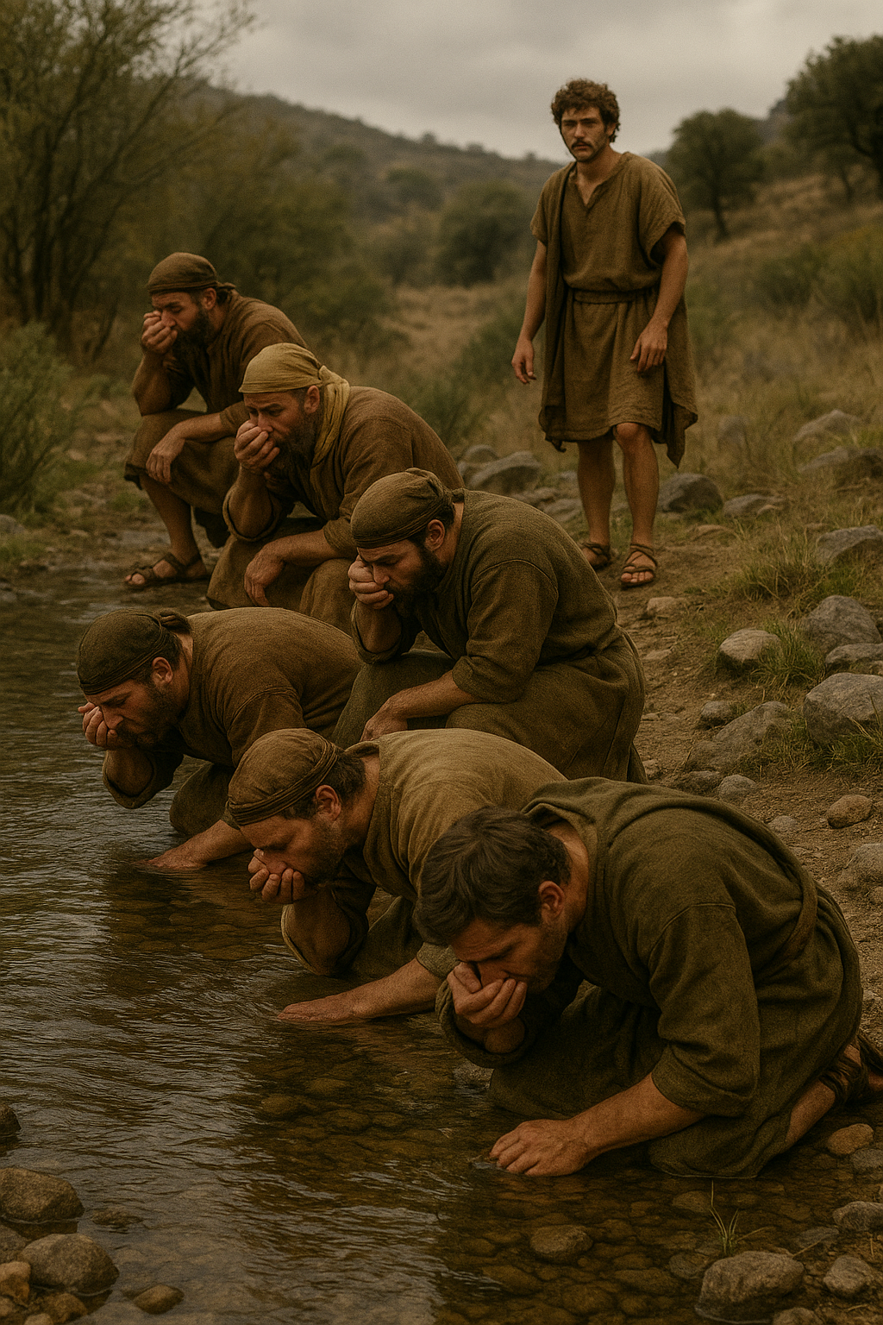

Matthew 25:1-9 – Bring extra oil

25 Then shall the kingdom of heaven be likened unto ten virgins, which took their lamps, and went forth to meet the bridegroom.
² And five of them were wise, and five were foolish.
³ They that were foolish took their lamps, and took no oil with them:
⁴ But the wise took oil in their vessels with their lamps.
⁵ While the bridegroom tarried, they all slumbered and slept.
⁶ And at midnight there was a cry made, Behold, the bridegroom cometh; go ye out to meet him.
⁷ Then all those virgins arose, and trimmed their lamps.
⁸ And the foolish said unto the wise, Give us of your oil; for our lamps are gone out.
⁹ But the wise answered, saying, Not so; lest there be not enough for us and you: but go ye rather to them that sell, and buy for yourselves.

