If words were bricks…what does your house look like?



Why are we talking about Words again?
We use words 7 days a week, not just Sunday.
What we say is always important

Comedy Mark Lowry
https://www.youtube.com/watch?v=Y3lp0z981iM
How Great thou Art – Home Free
https://www.youtube.com/watch?v=tXQpDDcrN-w

Death & Destruction
⚰️ Sayings That Casually Invoke Death or Destruction
Saying | Literal Implication
"I'm dying to see it" | You're so eager it’s killing you
"That scared me to death" | Fear so extreme it causes death
"That killed me (laughing)" | Intense laughter causing death
"I about had a heart attack" | Startling or fear expressed as fatal
"You’re killing me" | Mild frustration or exasperation framed as death
"Drop dead gorgeous" | Beauty described in terms of death
"I’d kill for a coffee" | Expressing desire with violence
"Over my dead body" | Extreme opposition, even unto death
"Slay the room" (comedy) | To impress so much it’s as if you caused death

Spiritually Inverted Sayings
🙊 Sayings That Are Spiritually Inverted or Misguided
Saying | Literal Implication
"Bless their heart" (sarcastic) | False kindness with underlying mockery
"God only knows" | Often said with frustration or dismissal
"The devil made me do it" | Avoidance of personal responsibility
"Go to hell" | A literal curse pronounced on another
"He’s a little demon" | Affectionate term for a child with demonic language
"That's heavenly" | Comparing earthly pleasure to the divine

The consequences of Words
Proverbs 18:21
²¹ Death and life are in the power of the tongue: and they that love it shall eat the fruit thereof.
Matthew 12:36-37 – Does this mean now or in the future?
³⁶ But I say unto you, That every idle word that men shall speak, they shall give account thereof in the day of judgment.
³⁷ For by thy words thou shalt be justified, and by thy words thou shalt be condemned.

Does your word “house” have a rock or a sand foundation?
Matthew 7:24-27
²⁴ Therefore whosoever heareth these sayings of mine, and doeth them, I will liken him unto a wise man, which built his house upon a rock:
²⁵ And the rain descended, and the floods came, and the winds blew, and beat upon that house; and it fell not: for it was founded upon a rock.
²⁶ And every one that heareth these sayings of mine, and doeth them not, shall be likened unto a foolish man, which built his house upon the sand:
²⁷ And the rain descended, and the floods came, and the winds blew, and beat upon that house; and it fell: and great was the fall of it.

What have you built with your words?

Mark 9:23
²³ Jesus said unto him, If thou canst believe, all things are possible to him that believeth.

Mark 11:23
²³ For verily I say unto you, that whosoever shall say unto this mountain, ‘Be thou removed, and be thou cast into the sea,’ and shall not doubt in his heart, but shall believe that those things which he saith shall come to pass, he shall have whatsoever he saith.

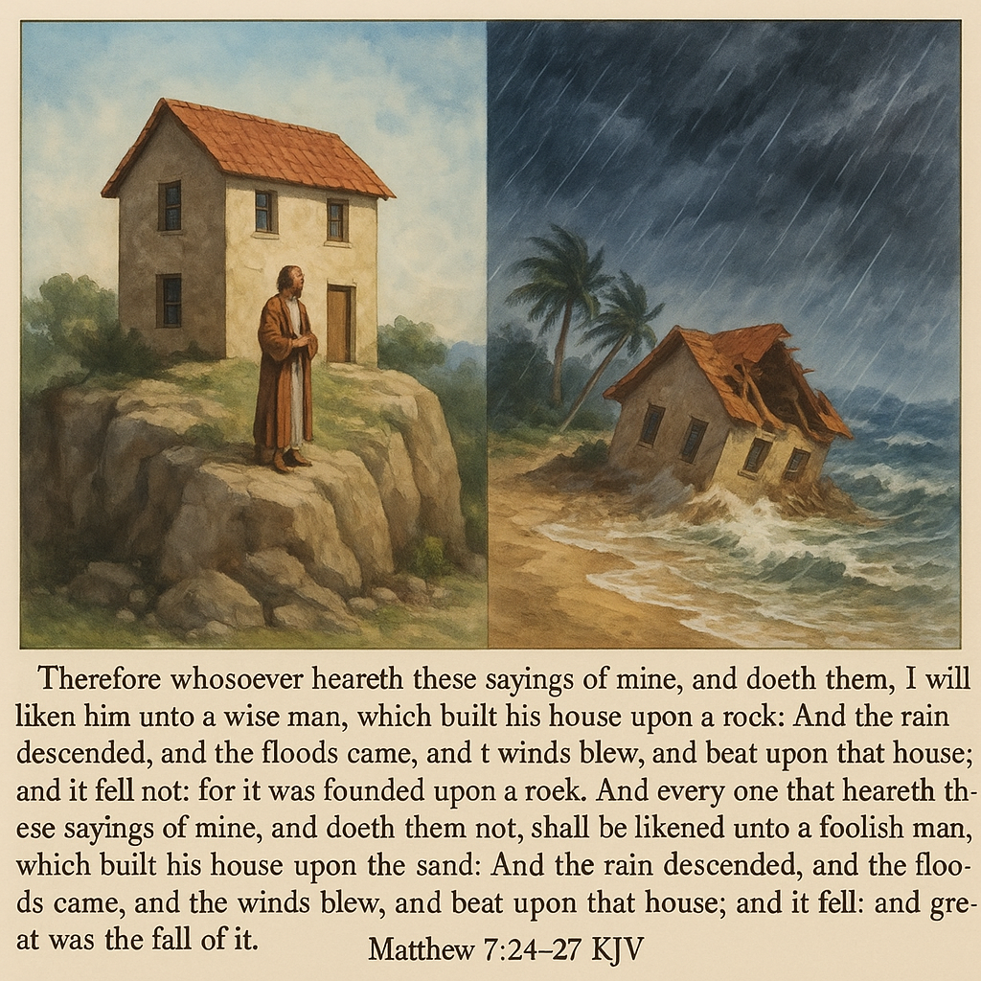

Matthew 7:24-27
²⁴ Therefore whosoever heareth these sayings of mine, and doeth them, I will liken him unto a wise man, which built his house upon a rock:
²⁵ And the rain descended, and the floods came, and the winds blew, and beat upon that house; and it fell not: for it was founded upon a rock.
²⁶ And every one that heareth these sayings of mine, and doeth them not, shall be likened unto a foolish man, which built his house upon the sand:
²⁷ And the rain descended, and the floods came, and the winds blew, and beat upon that house; and it fell: and great was the fall of it.

James 1:22-25
²² But be ye doers of the word, and not hearers only, deceiving your own selves.
²³ For if any be a hearer of the word, and not a doer, he is like unto a man beholding his natural face in a glass:
²⁴ For he beholdeth himself, and goeth his way, and straightway forgetteth what manner of man he was.
²⁵ But whoso looketh into the perfect law of liberty, and continueth therein, he being not a forgetful hearer, but a doer of the work, this man shall be blessed in his deed.

Matthew 5:37
³⁷ But let your communication be, Yea, yea; Nay, nay: for whatsoever is more than these cometh of evil.

Proverbs 15:1
“A soft answer turneth away wrath: but grievous words stir up anger.”

Romans 12:18
¹⁸ If it be possible, as much as lieth in you, live peaceably with all men.

Which house did you build with your words? – A house built on the rock?

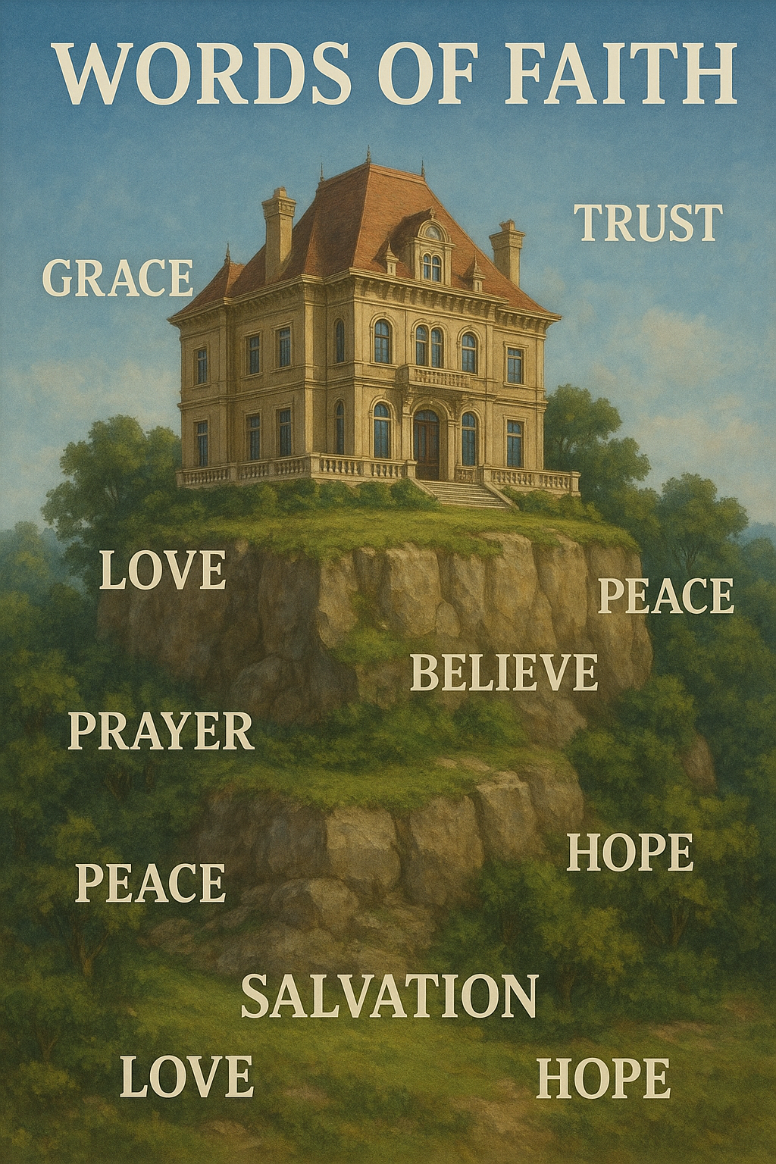

Which house did you build with your words? – A house over a sink hole?
So what if you did build your house over a sink hole? God gives grace like a 4 year old spreads peanut butter – he gets it all over the place and everywhere!
